**Ideation Phase**

**Define the Problem Statements**

|  |  |
| --- | --- |
| Date | 24 June 2025 |
| Team ID | LTVIP2025TMID20421 |
| Project Name | Streamlining Ticket Assignment For Efficient Support Operations |
| Mentor Name | Dr Shaik Salma Begum |
| Maximum Marks | 2 Marks |

**Customer Problem Statement**

**Who is the customer?**  
IT support agents and helpdesk teams within organizations using the ServiceNow platform.

**What is the problem?**  
Support agents are often overwhelmed by inefficient ticket assignment processes, leading to uneven workloads, delayed response times, and poor user satisfaction. Managers struggle with manual ticket routing, lack of real-time visibility into agent availability, and limited automation for priority or SLA-based assignments.

**When/where does the problem occur?**  
This occurs throughout daily support operations, especially during high-volume ticket inflow, shift changes, or when dealing with high-priority incidents that need immediate attention.

**What is the impact of the problem?**

* Increased ticket resolution time
* Decreased customer satisfaction
* Burnout among agents due to workload imbalance
* Escalations due to missed SLAs
* Poor visibility into performance metrics and bottlenecks

**Why does this matter?**  
If not addressed, the lack of a streamlined, automated ticket assignment process leads to inefficiencies that negatively affect both customer experience and team productivity. Organizations risk higher operational costs and lower service quality, which impacts business credibility.

**Empathy and Customer Viewpoint**

By focusing on these needs, the solution aims to empower IT support teams with intelligent tools that not only automate ticket assignment but also improve efficiency, reduce agent workload imbalance, and enhance service quality.

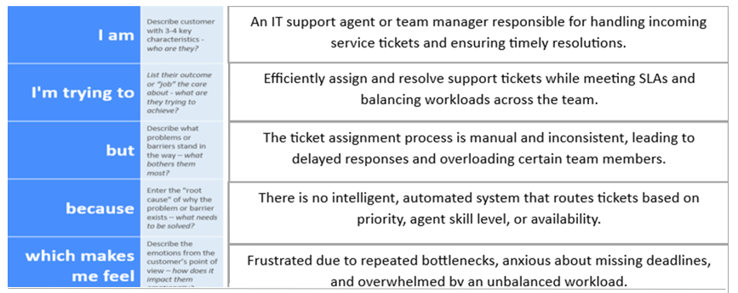

**Problem Statement Table – Streamlining Ticket Assignment**

| **Problem Statement (PS)** | **I am (Customer)** | **I’m trying to** | **But** | **Because** | **Which makes me feel** |
| --- | --- | --- | --- | --- | --- |
| **PS-1** | IT support agent | Resolve tickets quickly and on time | Tickets are assigned manually and unevenly | No smart assignment rules exist | Overwhelmed and stressed |
| **PS-2** | Support team manager | Balance workload across the team | Some agents are overloaded while others are idle | No visibility into current workload or skills | Frustrated and helpless |
| **PS-3** | SLA compliance officer | Ensure SLA deadlines are met | Tickets often miss response time targets | No automated escalation workflow | Anxious and under pressure |
| **PS-4** | ServiceNow admin | Automate ticket routing logic | Assignment requires custom scripts | No low-code automation tools are used | Restricted and delayed |
| **PS-5** | Support lead | Track team performance in real time | Dashboard data is outdated or missing | No real-time monitoring in place | Disconnected and uninformed |